**XAVIER UNIVERSITY – ATENEO DE CAGAYAN**

**COLLEGE OF COMPUTER STUDIES**

**DEPARTMENT OF COMPUTER SCIENCE**

**Brewery Inventory System**

I**n partial fulfillment of the requirements for the course  
CC14 – Database Systems and Information Management**

**Submitted by:**

**Gonzaga, Jose Miguel D.  
Paredes, Giancarlo S.**

**Submitted to:**

**Engr. Florence B. Reyes**

**October 15, 2019**

**TABLE OF CONTENTS**

**Page**

Cover page ------------------------------------------------------------------------------ 1  
Table of contents ----------------------------------------------------------------------- 2  
Executive summary -------------------------------------------------------------------- 3  
System Selection and Definition ----------------------------------------------------- 4 - 5

Conceptual & Logical Database Designs ------------------------------------------ 6 - 15

1. Data Dictionary --------------------------------------------------------- 8 - 15

Physical Database Design ---------------------------------------------------------- 16 - 22

1. Sample ERD’s -------------------------------------------------------- 23 - 30

Feedback, Conclusion and Recommendation -------------------------------------- 31

Appendix ------------------------------------------------------------------------------ 32 - 33

1. Curriculum Vitae -------------------------------------------------- 32 - 33

**Executive Summary**

This Database is aimed to create a Brewery Inventory System for sulawan Point stockholder of san Miguel located on El Salvator System, The database manages multiple core processes from Inventory of the stockholder and supplier to reports from inventory to purchase & sales. The main goal is to create a working Inventory system that functions properly while keeping everything relatively simple with all the required data used onto the database. Using the knowledge gained this semester we have created a working database that fits the needs of both the minimum requirements of the subject, as well as the requirements of the company - San Miguel within the given time.

**System Selection & Definition**

***Case Description: Brewery Inventory System***

General Description:

Sulawan Point is a stockholder of San Miguel in El Salvador city. It is a warehouse that stores different kinds of brewery made by San Miguel and it distributes and delivers them to each of its clients within the area. This projects purpose is to design how the inventory and the products goes in, out, and managed by the company.

Basic Operations:

The business sells different kinds of San Miguel related brewery products both alcohol and soft drinks to their clients, customer usually orders via the business’ telephone or phone number, first they order what product will they buy, how much, and when will it be delivered, then the customer/client will specify his/her name, address, phone number, and tin.

Whenever the customer buys a product to the company it must return case of bottles or bottles. If the bottles are completed and the case has the same type of alcohol or drinks there will be no payment penalty, however when there are missing bottle(s) or broken bottles there will be payment penalty and the cost will be the bottles value. (item cost).

Information needs:

All of the data will be stored and be contained in the company’s database for their usage such as the Customer’s Info, Inventory Quantity, Unit Cost, Purchases, and Sales. However, the Items cost will be based on the suppliers cost therefore it is possible the cost will change and it is not controlled by the company.

**1. Inventory** - ItemID, ItemName, Itemtype, ItemCost, UnitCost, ItemQty.

The Inventory Custodian opens the data and it will show all of the data in Inventory such as the item’s ID, name, type of beverage(alcohol or soft drinks), the cost(bought from the supplier), unit cost(sold to the customer), and quantity left in the warehouse. Furthermore, the Inventory Custodian can also modify and customize the data of the products in the inventory, such as the cost, unit cost, and quantity of the products.

**2. Customer Info** - CustID, CustName, CustAddress, CustContNumb, CustTIN, Date of Sales.

The purpose of this allows the Sales Manager to see the customer’s info and the date which the customer buys a product(s) on the company.

**3. Purchases** - PurchaseID, SupplierID, SupplierName, SupplierAddress,ItemID, Itemname, Itemtype, ItemQty, ItemCost, ItemTotalCost, Date of Purchase.

When the Sales Manager order products to the supplier, the company will ask the Suppliers name and address and then orders the Item’s name, type, and quantity and the product.

**4. Sales** - SalesID, CustID, CustName, CustAddress, CustContNumb, CustTIN, ItemID, ItemName, Itemtype, ItemQty, UnitCost, UnitTotalCost,Date of Sale.

When the customer orders a product to the company, the customer will order what product and the amount that will be bought. After that the company will ask the customers name, address, contact number, and tax identification number (tin). The unitTotalCost and Date of Sale will also be inputted.

**Conceptual & Logical Database Design**

***Brewery Inventory Management Database***

User’s Requirement Specification

The Company wants to keep track of its inventory, customers, reports, suppliers, supply, and payments.

***(1)*** The company hires a sales manager who organizes and is in contact with the customer. The Sales Manager info must be present such as unique name, contact number, and date of birth. The customer has a unique ID, Last name, contact number, tax identification number, and address. The customer can order few or many product(s) from the company by requesting an order issue to the Sales Manager. The order consists of a unique order number, ordered item name, and ordered item quantity

***(2)*** The Sales Manager will receive the order and file an Order report to the Inventory custodian. The order report consists of unique order report number and the ordered date.

***(3)*** The company hires an Inventory Custodian and the info must also be present such as unique name, contact number, and date of birth. The Inventory Custodians job is to check whether there is enough/sufficient amount of supplies in the Inventory. The inventory has a unique Item ID, Item type, Item Cost, Unit Cost, Item total quantity, Item Name. After checking the Inventory Custodian files an Inventory Report is made to relay information whether the supplies are sufficient or not. The Inventory report has its unique inventory report number and inventory report date.

***(4)*** In an event where the amount of supplies is insufficient in the Inventory, the Sales Manager will contact the company’s supplier and requests an order. The supplier has its own unique supplier ID, name, address and contact number. After managing the payments, the supplies will be delivered from the supplier to the company. The supplies have their own unique supply ID, name, type and quantity. After the delivery of supplies, the Sales Manager will file a purchase report to the Inventory Custodian. The purchase report consists of a unique purchase report number and purchase date.

***(5)*** Then the Sales Manager will deliver the products to the customer and the customer will pay the Sales Manager either through CC (Credit Card) or Cash and the payment has a unique payment number. After receiving payment from the Customer, the Sales Manager will file a sales report that consists of sales report number and sales date and the sales report will be sent and received by the Inventory Custodian.

Conceptual Data Model

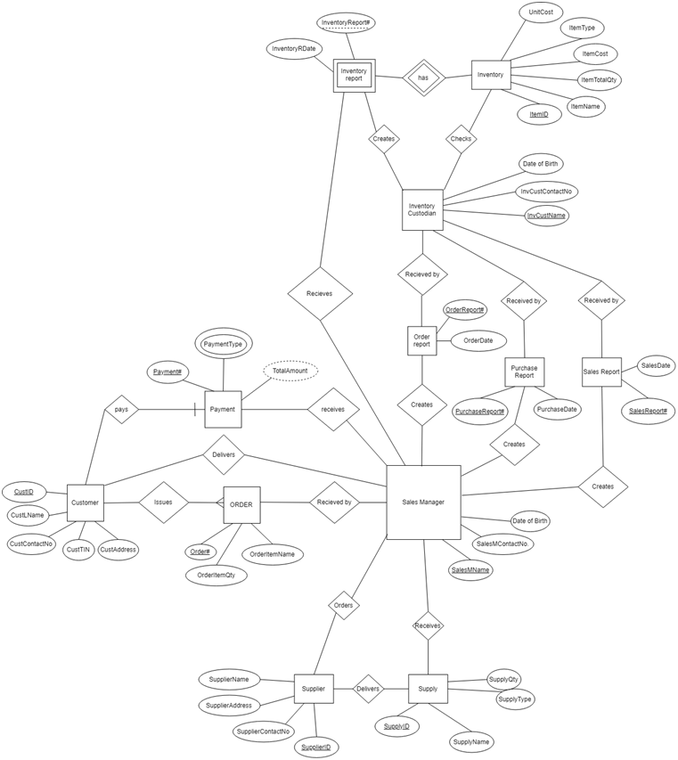

Logical Data Model

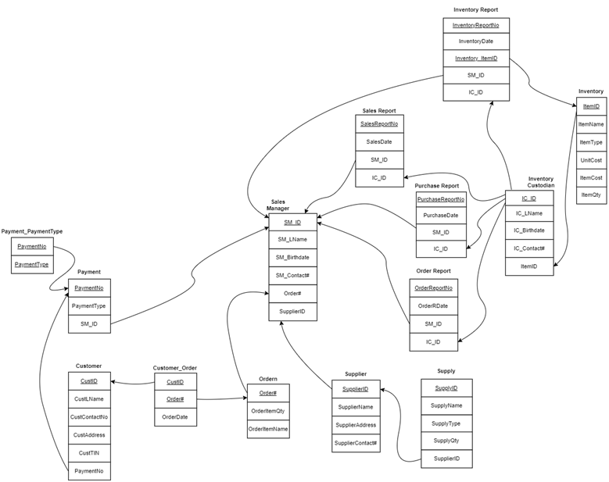

**Data Dictionary**

|  |  |  |  |  |  |  |  |  |
| --- | --- | --- | --- | --- | --- | --- | --- | --- |
| Table Name | Attribute Name | Contents | Type | Format | Range | Required | PK or FK | Ref Table |
| Customer | CustID | Customer Code | CHAR(5) | 99999 | 1 - 99999 | Y | PK |  |
| CustLName | Customer Name | VARCHAR(20) | Xxxxxxxx |  | Y |  |  |
| CustComtNo | Customer Phone No. | CHAR (15) | 00000000 | 0 - 9999999 | Y |  |  |
| CustAddress | Customer Home Address | VARCHAR(50) | Blk00-Lot00-Xxxxxx |  | Y |  |  |
| CustTIN | Customer Tax Identification Number | NUMBER (12) | 00000000 | 0 - 9999999 | Y |  |  |
| Payment# | Payment No. | CHAR(5) | 00000 | 1 - 99999 | Y | FK | Payment |
|  | | | | | | | | |
| Order | Order# | Order No. | CHAR(5) | 99999 | 1 - 99999 | Y | PK |  |
| OrderItemQty | Ordered Item Quantity | Num Ber (4) | 0000 | 0 - 9999 | Y |  |  |
| OrderItemName | Ordered Item Name | VAR CHAR (20) | Xxxxxxxx |  | Y |  |  |
| CustID | Customer ID | CHAR(5) | 99999 | 1 - 99999 | Y | FK | Customer |
|  | | | | | | | | |
| Sales Manager | SalesMName | SalesMName | VAR CHAR (30) | Xxxxxxxx |  | Y | PK |  |
| ContactNumber | Phone no. | CHAR(15) | 00000000 | 0 - 9999999 | Y |  |  |
| Date of Birth | Date of birth | Date | dd-mm-yyyy |  |  |  |  |
| Order# | Order No. | CHAR(5) | 99999 | 1 - 99999 | Y | FK | Order |
| SupplierID | Supply ID | CHAR(5) | 00000 | 1 - 99999 | Y | FK | Supplier |
|  | | | | | | | | |
| Payment | Payment# | Payment No. | CHAR(5) | 99999 | 1 - 99999 | Y | PK |  |
| PaymentType | Payment Type | VAR CHAR (4) | Xxxx | CC or Cash | Y |  |  |
| TotalAmount | Total Amount | Num Ber (9) | 0000000.00 | 0.00-9999999.99 | Y |  |  |
| SalesMName | SalesMName | VAR CHAR (30) | Xxxxxxxx |  | Y | FK | Sales Manager |
|  | | | | | | | | |
| Supplier | SupplierID | Supplier ID | CHAR(5) | 00000 | 1 - 99999 | Y | PK |  |
| SupplierName | Supplier’s Name | VAR CHAR (20) | Xxxxxxx |  | Y |  |  |
| SupplierAddress | Supplier’s Address | VAR CHAR (50) | Xxxxxxx |  | Y |  |  |
| SupplyID | Supply ID | CHAR(5) | 00000 | 1 - 99999 | Y | FK | Supply |

|  |  |  |  |  |  |  |  |  |
| --- | --- | --- | --- | --- | --- | --- | --- | --- |
| Table Name | Attribute Name | Contents | Type | Format | Range | Required | PK  or  FK | Ref Table |
| Supply | SupplyID | Supply ID | CHAR(5) | 00000 | 1 - 99999 | Y | PK |  |
| SupplyName | Supply  Item  Name | VAR CHAR (20) | Xxxxxxx |  | Y |  |  |
| SupplyType | Supply  Item  Type | VAR CHAR (20) | Xxxxxxxx | Alcohol or Softdrinks | Y |  |  |
| SupplyQty | Supply  Item  Quantity | Number (4) | 0000 | 0 - 9999 | Y |  |  |
| SupplyTotalAmount | Total  Amount | Number (9) | 0000000.00 | 0.00-9999999.99 | Y |  |  |
| SalesMName | Sales MName | VAR CHAR (20) | Xxxxxxxx |  | Y | FK | Sales Manager |
|  | | | | | | | | |
| Order Report | OrderReport# | Order  Report  No. | CHAR(5) | 99999 | 1 - 99999 | Y | PK |  |
| OrderDate | Ordered  Date | Date | dd-mm-yyyy |  | Y |  |  |
| SalesMName | Sales MName | VAR CHAR (30) | Xxxxxxxx |  | Y | FK | Sales Manager |
| InvCustName | InvCust Name | VAR CHAR (30) | Xxxxxxxx |  | Y | FK | Inventory  Custodian |
|  | | | | | | | | |
| Sales Report | SalesReport# | Sales No. | CHAR(5) | 00000 | 1 - 99999 | Y | PK |  |
| Date of Sales | Date of Sale | Date | dd-mm-yyyy |  | Y |  |  |
| SalesMName | Sales MName | VAR CHAR (30) | Xxxxxxxx |  | Y | FK | Sales  Manager |
| InvCustName | InvCust  Name | VAR CHAR (20) | Xxxxxxxx |  | Y | FK | Inventory  Custodian |
|  | | | | | | | | |
| Purchase Report | Purchase# | InvCust No. | CHAR(5) | 00000 | 1 - 99999 | Y | PK |  |
| Date  Of  Purchase | Date  of  Purchase | Date | dd-mm-yyyy |  | Y |  |  |
| SalesMName | SalesMName | VAR CHAR (30) | Xxxxxxxx |  | Y | FK | Sales Manager |
| InvCustName | InvCust  Name | VAR CHAR (20) | Xxxxxxxx |  | Y | FK | Inventory Custodian |
|  | | | | | | | | |
| Inventory Custodian | InvCustName | InvCust Name | VAR CHAR (20) | Xxxxxxxx |  | Y | PK |  |
| ContactNumber | Phone no. | CHAR(15) | 00000000 | 0 - 9999999 | Y |  |  |
| Date of Birth | Date of birth | Date | dd-mm-yyyy |  |  |  |  |
| ItemID | Item ID | CHAR(5) | 00000 | 1 - 99999 | Y | FK | Inventory |

|  |  |  |  |  |  |  |  |  |
| --- | --- | --- | --- | --- | --- | --- | --- | --- |
| Table Name | Attribute Name | Contents | Type | Format | Range | Required | PK or FK | Ref Table |
| Inventory | ItemID | Item ID | CHAR(5) | 00000 | 1 - 99999 | Y | PK |  |
| ItemType | Item Type | VAR CHAR (10) | Xxxxxxxx | Alcohol  or Soft drinks | Y |  |  |
| ItemName | Item Name | VARCHAR(20) | Xxxxxxxx |  | Y |  |  |
| ItemCost | Item Cost | Number(5) | 00000.00 | 0.00 - 999.99 | Y |  |  |
| UnitCost | Unit Cost | Number(5) | 00000.00 | 0.00 - 999.99 | Y |  |  |
| ItemQty | Quantity | Number(4) | 0000 | 0 - 9999 | Y |  |  |
|  | | | | | | | | |
| Inventory Report | InventoryReport# | Inventory Report No. | CHAR(5) | 00000 | 1 - 99999 | Y | PK |  |
| InventoryRDate | Inventory Report Date | Date | dd-mm-yyyy |  | Y |  |  |
| Inventory_ItemID | ItemID | CHAR(5) | 00000 | 1 - 99999 | Y | FK | Inventory |
| SalesMName | SalesMName | VARCHAR(30) | Xxxxxxxx |  | Y | FK | Sales Manager |

**Physical Database Design**

CREATE TABLE `customer` (

`CustomerID` int(11) NOT NULL,

`CustLName` varchar(30) NOT NULL,

`CustContactNo` char(15) NOT NULL,

`CustAddress` varchar(50) NOT NULL,

`CustTIN` int(12) NOT NULL,

`PaymentNo` int(11) NOT NULL,

PRIMARY KEY (`CustomerID`),

UNIQUE KEY `CustomerID_UNIQUE` (`CustomerID`),

KEY `PaymentNo_idx` (`PaymentNo`),

CONSTRAINT `PaymentNo` FOREIGN KEY (`PaymentNo`) REFERENCES `payment` (`PaymentNo`) ON DELETE RESTRICT ON UPDATE CASCADE

)

CREATE TABLE `customer_has_order` (

`customer_CustomerID` int(11) NOT NULL,

`order_Order#` int(11) NOT NULL,

`OrderDate` date NOT NULL,

PRIMARY KEY (`customer_CustomerID`,`order_Order#`),

KEY `fk_customer_has_order_order1_idx` (`order_Order#`),

CONSTRAINT `fk_customer_has_order_customer` FOREIGN KEY (`customer_CustomerID`) REFERENCES `customer` (`CustomerID`) ON DELETE RESTRICT ON UPDATE CASCADE,

CONSTRAINT `fk_customer_has_order_order1` FOREIGN KEY (`order_Order#`) REFERENCES `ordern` (`Order#`) ON DELETE RESTRICT ON UPDATE CASCADE

)

CREATE TABLE `inventory` (

`ItemID` int(5) NOT NULL,

`ItemName` varchar(20) NOT NULL,

`ItemType` varchar(10) NOT NULL,

`UnitCost` int(5) NOT NULL,

`ItemCost` int(5) NOT NULL,

`ItemQty` int(4) NOT NULL,

PRIMARY KEY (`ItemID`),

UNIQUE KEY `ItemID_UNIQUE` (`ItemID`)

)

CREATE TABLE `inventory_report` (

`InventoryReportNo` int(11) NOT NULL,

`InventoryDate` date NOT NULL,

`inventorycustodian_IC_ID` int(11) NOT NULL,

`inventory_ItemID` int(5) NOT NULL,

`salesmanager_SM_ID` int(11) NOT NULL,

PRIMARY KEY (`InventoryReportNo`,`inventory_ItemID`),

UNIQUE KEY `InventoryReportNo_UNIQUE` (`InventoryReportNo`),

KEY `fk_inventory_report_salesmanager1_idx` (`salesmanager_SM_ID`),

KEY `fk_inventory_report_inventorycustodian1_idx` (`inventory_ItemID`),

KEY `inventorycustodian_IC_ID_idx` (`inventorycustodian_IC_ID`),

CONSTRAINT `fk_inventory_report_inventorycustodian1` FOREIGN KEY (`inventory_ItemID`) REFERENCES `inventorycustodian` (`inventory_ItemID`) ON DELETE RESTRICT ON UPDATE CASCADE,

CONSTRAINT `fk_inventory_report_salesmanager1` FOREIGN KEY (`salesmanager_SM_ID`) REFERENCES `salesmanager` (`SM_ID`) ON DELETE RESTRICT ON UPDATE CASCADE,

CONSTRAINT `inventorycustodian_IC_ID` FOREIGN KEY (`inventorycustodian_IC_ID`) REFERENCES `inventorycustodian` (`IC_ID`)

)

CREATE TABLE `inventorycustodian` (

`IC_ID` int(11) NOT NULL,

`IC_LName` varchar(50) NOT NULL,

`IC_BirthDate` date NOT NULL,

`IC_Contact#` char(15) NOT NULL,

`inventory_ItemID` int(5) NOT NULL,

PRIMARY KEY (`IC_ID`),

UNIQUE KEY `IC_ID_UNIQUE` (`IC_ID`),

KEY `fk_inventorycustodian_inventory1_idx` (`inventory_ItemID`),

CONSTRAINT `ItemID` FOREIGN KEY (`inventory_ItemID`) REFERENCES `inventory` (`ItemID`) ON DELETE RESTRICT ON UPDATE CASCADE

)

CREATE TABLE `order_report` (

`OrderReportNo` int(11) NOT NULL,

`OrderRDate` date NOT NULL,

`salesmanager_SM_ID` int(11) NOT NULL,

`inventorycustodian_IC_ID` int(11) NOT NULL,

PRIMARY KEY (`OrderReportNo`),

UNIQUE KEY `OrderReportNo_UNIQUE` (`OrderReportNo`),

KEY `fk_order_report_salesmanager1_idx` (`salesmanager_SM_ID`),

KEY `fk_order_report_inventorycustodian1_idx` (`inventorycustodian_IC_ID`),

CONSTRAINT `fk_order_report_inventorycustodian1` FOREIGN KEY (`inventorycustodian_IC_ID`) REFERENCES `inventorycustodian` (`IC_ID`) ON DELETE RESTRICT ON UPDATE CASCADE,

CONSTRAINT `fk_order_report_salesmanager1` FOREIGN KEY (`salesmanager_SM_ID`) REFERENCES `salesmanager` (`SM_ID`) ON DELETE RESTRICT ON UPDATE CASCADE

)

CREATE TABLE `ordern` (

`Order#` int(11) NOT NULL,

`OrderItemQty` int(4) NOT NULL,

`OrderItemName` varchar(20) NOT NULL,

PRIMARY KEY (`Order#`),

UNIQUE KEY `Order#_UNIQUE` (`Order#`)

)

CREATE TABLE `payment` (

`PaymentNo` int(11) NOT NULL,

`PaymentType` varchar(4) NOT NULL,

`salesmanager_SM_ID` int(11) NOT NULL,

PRIMARY KEY (`PaymentNo`),

UNIQUE KEY `PaymentNo_UNIQUE` (`PaymentNo`),

KEY `fk_payment_salesmanager1_idx` (`salesmanager_SM_ID`),

CONSTRAINT `fk_payment_salesmanager1` FOREIGN KEY (`salesmanager_SM_ID`) REFERENCES `salesmanager` (`SM_ID`)

)

CREATE TABLE `payment_paymenttype` (

`payment_PaymentNo` int(11) NOT NULL,

`PaymentType` varchar(4) NOT NULL,

PRIMARY KEY (`payment_PaymentNo`,`PaymentType`),

KEY `fk_payment_paymenttype_payment1_idx` (`payment_PaymentNo`),

CONSTRAINT `fk_payment_paymenttype_payment1` FOREIGN KEY (`payment_PaymentNo`) REFERENCES `payment` (`PaymentNo`) ON DELETE RESTRICT ON UPDATE CASCADE

)

CREATE TABLE `purchase_report` (

`PurchaseReportNo` int(11) NOT NULL,

`PurchaseDate` date NOT NULL,

`salesmanager_SM_ID` int(11) NOT NULL,

`inventorycustodian_IC_ID` int(11) NOT NULL,

PRIMARY KEY (`PurchaseReportNo`),

UNIQUE KEY `PurchaseReportNo_UNIQUE` (`PurchaseReportNo`),

KEY `fk_purchase_report_salesmanager1_idx` (`salesmanager_SM_ID`),

KEY `fk_purchase_report_inventorycustodian1_idx` (`inventorycustodian_IC_ID`),

CONSTRAINT `fk_purchase_report_inventorycustodian1` FOREIGN KEY (`inventorycustodian_IC_ID`) REFERENCES `inventorycustodian` (`IC_ID`),

CONSTRAINT `fk_purchase_report_salesmanager1` FOREIGN KEY (`salesmanager_SM_ID`) REFERENCES `salesmanager` (`SM_ID`)

)

CREATE TABLE `sales_report` (

`SalesReportNo` int(11) NOT NULL,

`SalesDate` date NOT NULL,

`salesmanager_SM_ID` int(11) NOT NULL,

`inventorycustodian_IC_ID` int(11) NOT NULL,

PRIMARY KEY (`SalesReportNo`),

UNIQUE KEY `SalesReportNo_UNIQUE` (`SalesReportNo`),

KEY `fk_sales_report_salesmanager1_idx` (`salesmanager_SM_ID`),

KEY `fk_sales_report_inventorycustodian1_idx` (`inventorycustodian_IC_ID`),

CONSTRAINT `fk_sales_report_inventorycustodian1` FOREIGN KEY (`inventorycustodian_IC_ID`) REFERENCES `inventorycustodian` (`IC_ID`),

CONSTRAINT `fk_sales_report_salesmanager1` FOREIGN KEY (`salesmanager_SM_ID`) REFERENCES `salesmanager` (`SM_ID`)

)

CREATE TABLE `salesmanager` (

`SM_ID` int(11) NOT NULL,

`SM_LName` varchar(50) NOT NULL,

`SM_BirthDate` date NOT NULL,

`SM_Contact#` char(15) NOT NULL,

`Order#` int(11) NOT NULL,

`supplier_SupplierID` int(11) NOT NULL,

PRIMARY KEY (`SM_ID`),

UNIQUE KEY `SM_ID_UNIQUE` (`SM_ID`),

KEY `fk_salesmanager_supplier1_idx` (`supplier_SupplierID`),

KEY `Order#_idx` (`Order#`),

CONSTRAINT `Order#` FOREIGN KEY (`Order#`) REFERENCES `ordern` (`Order#`) ON DELETE RESTRICT ON UPDATE CASCADE,

CONSTRAINT `fk_salesmanager_supplier1` FOREIGN KEY (`supplier_SupplierID`) REFERENCES `supplier` (`SupplierID`) ON DELETE RESTRICT ON UPDATE CASCADE

)

CREATE TABLE `supplier` (

`SupplierID` int(11) NOT NULL,

`SupplierName` varchar(20) NOT NULL,

`SupplierAddress` varchar(50) NOT NULL,

`SupplierContact#` char(15) NOT NULL,

PRIMARY KEY (`SupplierID`),

UNIQUE KEY `SupplierID_UNIQUE` (`SupplierID`)

)

CREATE TABLE `supply` (

`SupplyID` int(11) NOT NULL,

`SupplyName` varchar(20) NOT NULL,

`SupplyType` varchar(20) NOT NULL,

`SupplyQty` int(4) NOT NULL,

`SupplierID` int(11) NOT NULL,

PRIMARY KEY (`SupplyID`),

UNIQUE KEY `SupplyID_UNIQUE` (`SupplyID`),

KEY `SupplierID_idx` (`SupplierID`),

CONSTRAINT `SupplierID` FOREIGN KEY (`SupplierID`) REFERENCES `supplier` (`SupplierID`) ON DELETE RESTRICT ON UPDATE CASCADE

)

**SAMPLE ERD (WORKBENCH)**

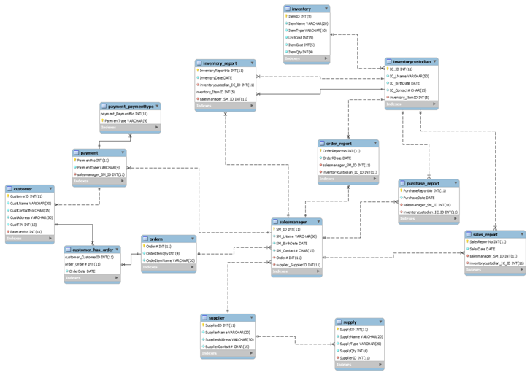

**SAMPLE TABLE (workbench)**

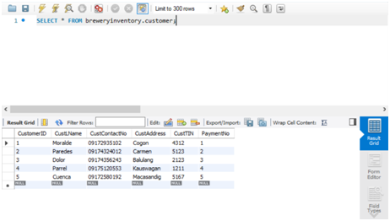  
  
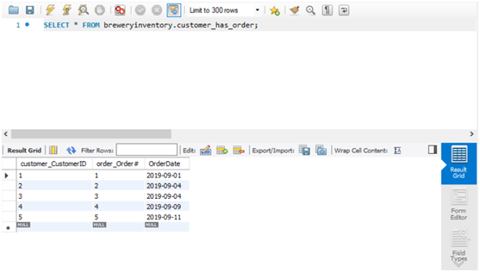

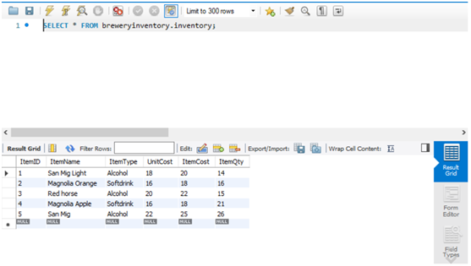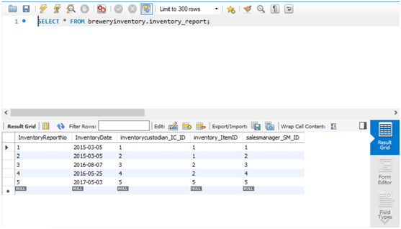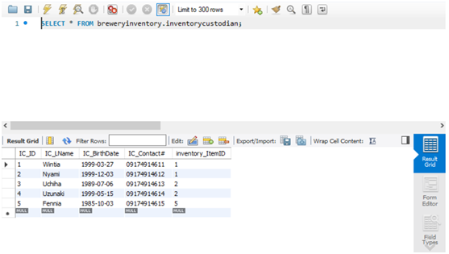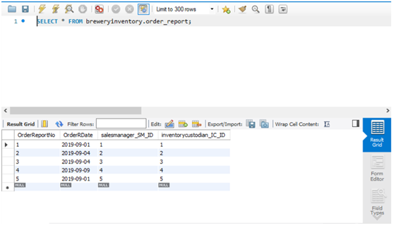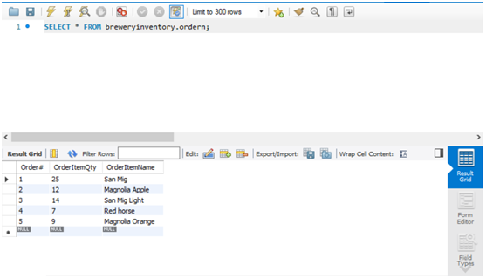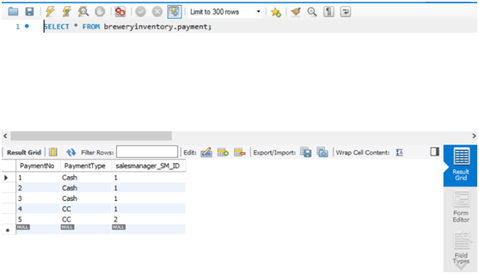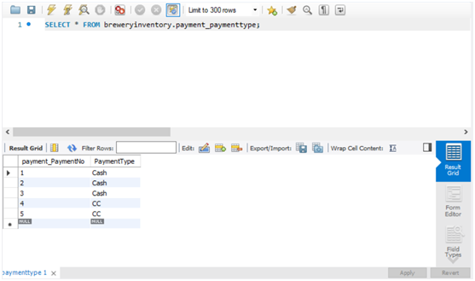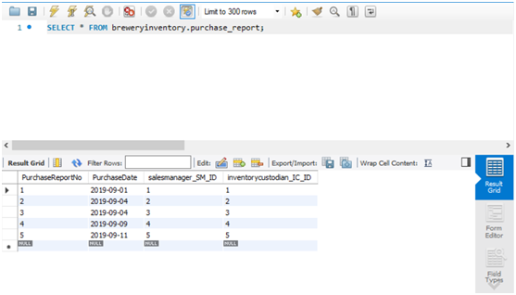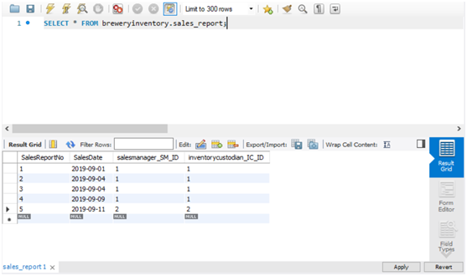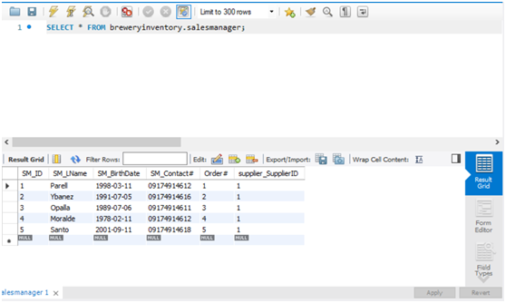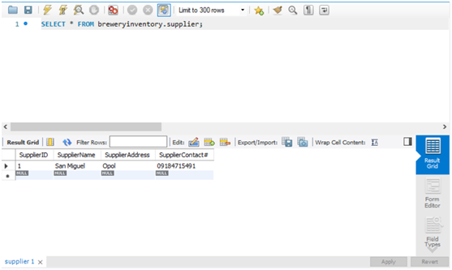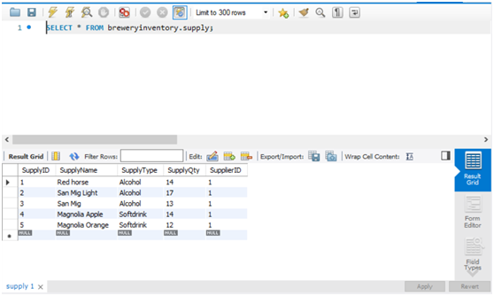

**Feedback, Conclusion and Recommendation**

This database focuses on the transaction of supplies, reports, payments, recording customers, suppliers, sales managers, ordered items, inventory, and inventory custodian

The scope of this database is low because of the lack of time to make in one month in creating the database. Furthermore, the database is very focused only to the company rather than other variables such as what kind of payment will the company for the supplied given and many more details that aren’t included due to the lack of time. I recommend that in the further development of this database is that it will include variables that will make the database more detailed like real life since the database has still a small scope and has a lot of limitations due to time.

Lastly, this database would be more visually appealing if there is a GUI (Graphic User Interface) in order to make the database less complex and more user friendly.

**Appendix**

**CURRICULUM VITAE**

Name: Gonzaga, Jose Miguel Dulhao

Address: Blk 8 Lot 52, Gold City Phase II, Balulang, Cagayan De Oro City, Misamis Oriental

Contact Number: 09174914610

Email: josemiguelgonzaga467@gmail.com

Occupation: student of Computer Studies: BS Computer Science in Xavier University: Ateneo De Cagayan

**PERSONAL DATA**

Nationality : Filipino

Religion : Roman Catholic

Sex: Male

Date of Birth : March 27, 1999

**EDUCATION**

2017 - 2018 : Graduate of Senior High School in Corpus Christi, Macasandig, Cagayan De Oro

2015 - 2016 : Graduate of Junior High School in Corpus Christi, Macasandig, Cagayan De Oro

2011 - 2012 : Graduate of Elementary School in Corpus Christi, Macasandig, Cagayan De Oro

**CURRICULUM VITAE**

Name: Paredes, Giancarlo Seno

Address: Orange St, Greenland Heights, Zone 10, Purok 5, Upper Carmen, Cagayan De Oro City.

Contact Number: 09953574137

Email: [gianwalls@yahoo.com](mailto:gianwalls@yahoo.com) / gsologamer17@gmail.com

Occupation: student of Computer Studies: BS Computer Science in Xavier University: Ateneo De Cagayan

**PERSONAL DATA**

Nationality : Filipino

Religion : Born Again

Sex: Male

Date of Birth : April 17, 2000

**EDUCATION**

2017 - 2018 : Graduate of Senior High School in Xavier University Senior High, Cagayan De Oro

2015 - 2016 : Graduate of Junior High School in Xavier University Junior High, Cagayan De Oro

2012 - 2013 : Graduate of Elementary School in Xavier University Grade School, Cagayan De Oro